 | 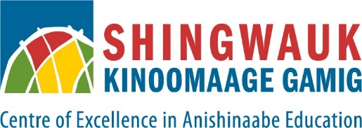

FOR IMMEDIATE RELEASE

Landmark Partnership to Accredit Indigenous Land Stewardship Program with
Wahkohtowin Development and Shingwauk Kinoomaage Gamig Announced

February 6, 2025 – Bawaating/Sault Ste. Marie, ON – At the Indigenous Land Symposium taking place this week, Wahkohtowin Development and Shingwauk Kinoomaage Gamig (SKG) proudly announced a groundbreaking partnership to accredit the Wahkohtowin Guardian Program, recognizing Indigenous Knowledge and land stewardship as integral components of academic learning.
Through this agreement, participants who complete the Wahkohtowin Guardian Program will receive accredited high school and post-secondary credits, providing new educational pathways that blend traditional ecological knowledge with formal academic recognition.
“This partnership is a transformative step in recognizing the value of Indigenous land stewardship within the academic landscape,” said David Flood at Wahkohtowin Development.
“By formalizing accreditation, we are bridging traditional knowledge with contemporary education, and further we are grounding practices that have been practiced for generations as part of the praxis that is used to manage the land this in turn creates pathways for Indigenous students to thrive while maintaining a strong connection to their culture and lands,” he added.
The Wahkohtowin Guardian Program equips Indigenous land stewards with skills in conservation, environmental monitoring, and cultural knowledge, ensuring the protection and management of traditional territories.
By partnering with SKG, a leading Indigenous-led post-secondary institution dedicated to Anishinaabe education and cultural preservation, this initiative strengthens opportunities for Indigenous learners to advance their academic and professional aspirations.
"This collaboration ensures that Indigenous Knowledge and land stewardship are not only preserved but also formally recognized within our education systems," stated Mary Wabano-McKay, President and Chief Academic Officer at Shingwauk Kinoomaage Gamig.
"Through this initiative, we are creating meaningful educational opportunities that empower Indigenous learners and communities," she added.
This agreement marks a significant milestone in strengthening Indigenous-led education through an experientially based program that is more relevant and aligned with the needs of Indigenous youth while supporting self-determined economic development, and fostering a deeper connection between Indigenous Knowledge and academic institutions.
- 30 -

For media inquiries, please contact:
David Flood
Wahkohtowin Development
wdgpi.gm@wahkohtowin.com
Mary Wabano-McKay
President / Chief Academic Officer
Shingwauk Kinoomaage Gamig
mary.wabano-mckay@shingwauku.org

